**PYTHON MINI PROJECT**

#PROBLEM STATEMENT:- Analyzing CoronaVirus With Python

#TEAM MEMBERS DETAILS:-

NAME : PARTH MEHANDRU SRN : PES1UG22EC190

NAME : SUKRUTH BHARADWAJ SRN : PES1UG22EC240

NAME : RITHESH M N SRN : PES1UG22EC300

#INPUT TO THE PROJECT:-

CSV FILES:



IMAGE FOR TKINTER WINDOW:



TKINTER ICON IMAGE:



SITE FOR DATASET:

<https://data.humdata.org/dataset/novel-coronavirus-2019-ncov-cases>

BACKGROUND IMAGE FOR TKINTER WINDOW:



#EXPECTED OUTPUT:-

**NEW CASES**

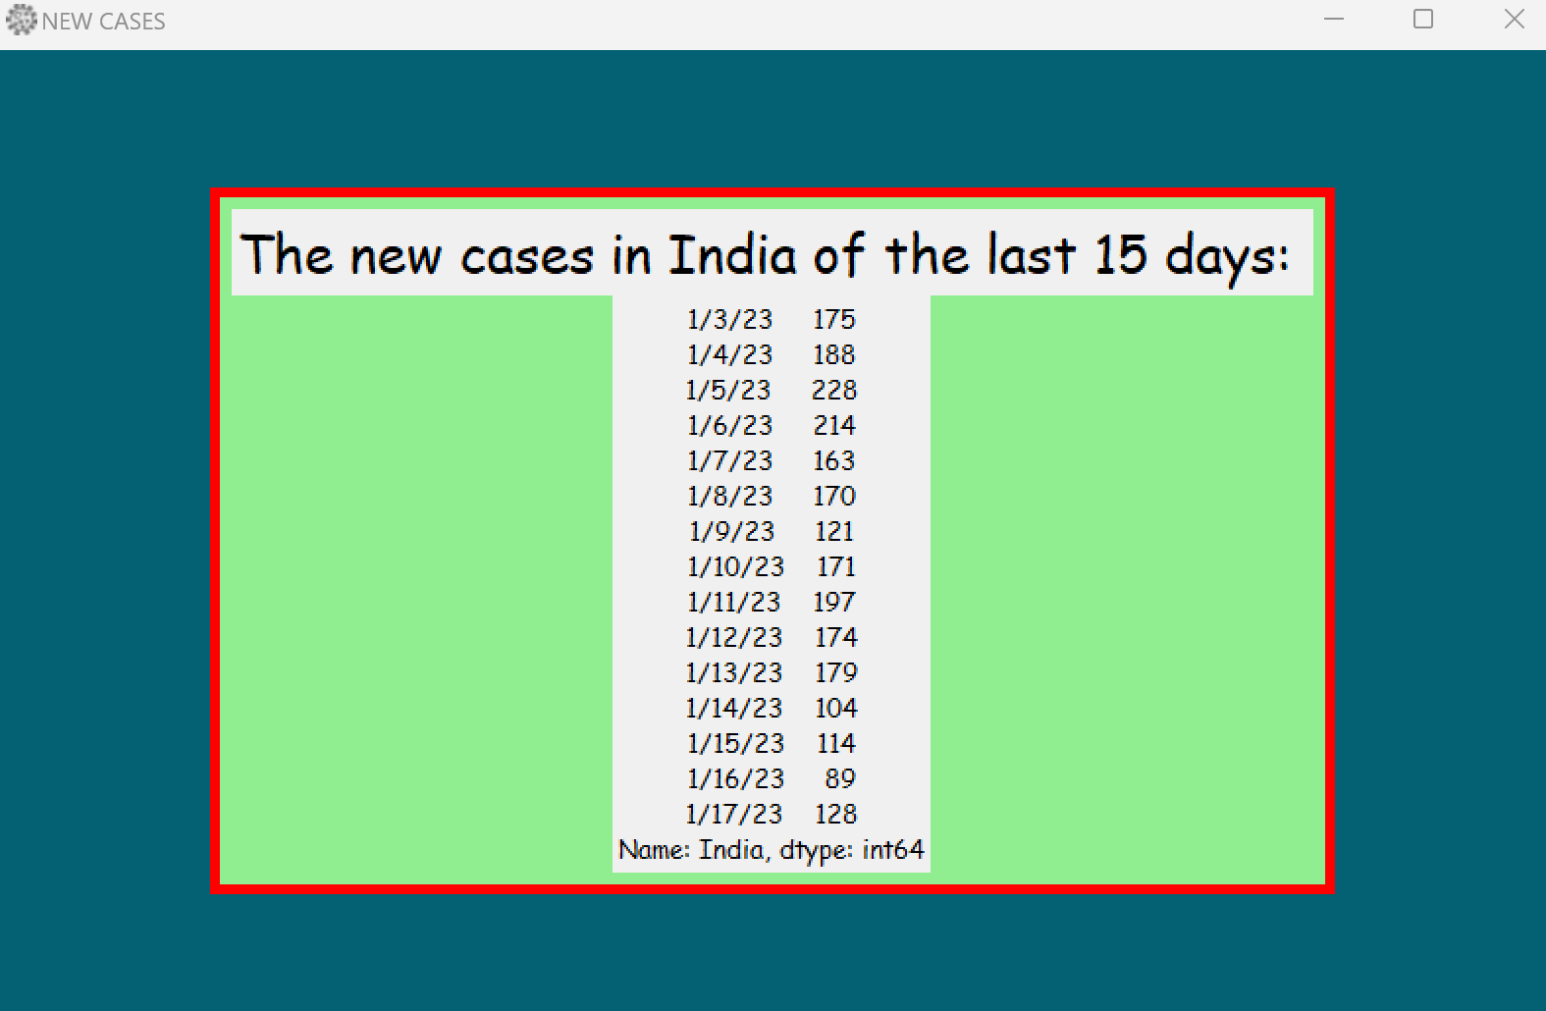

**GROWTH RATE**

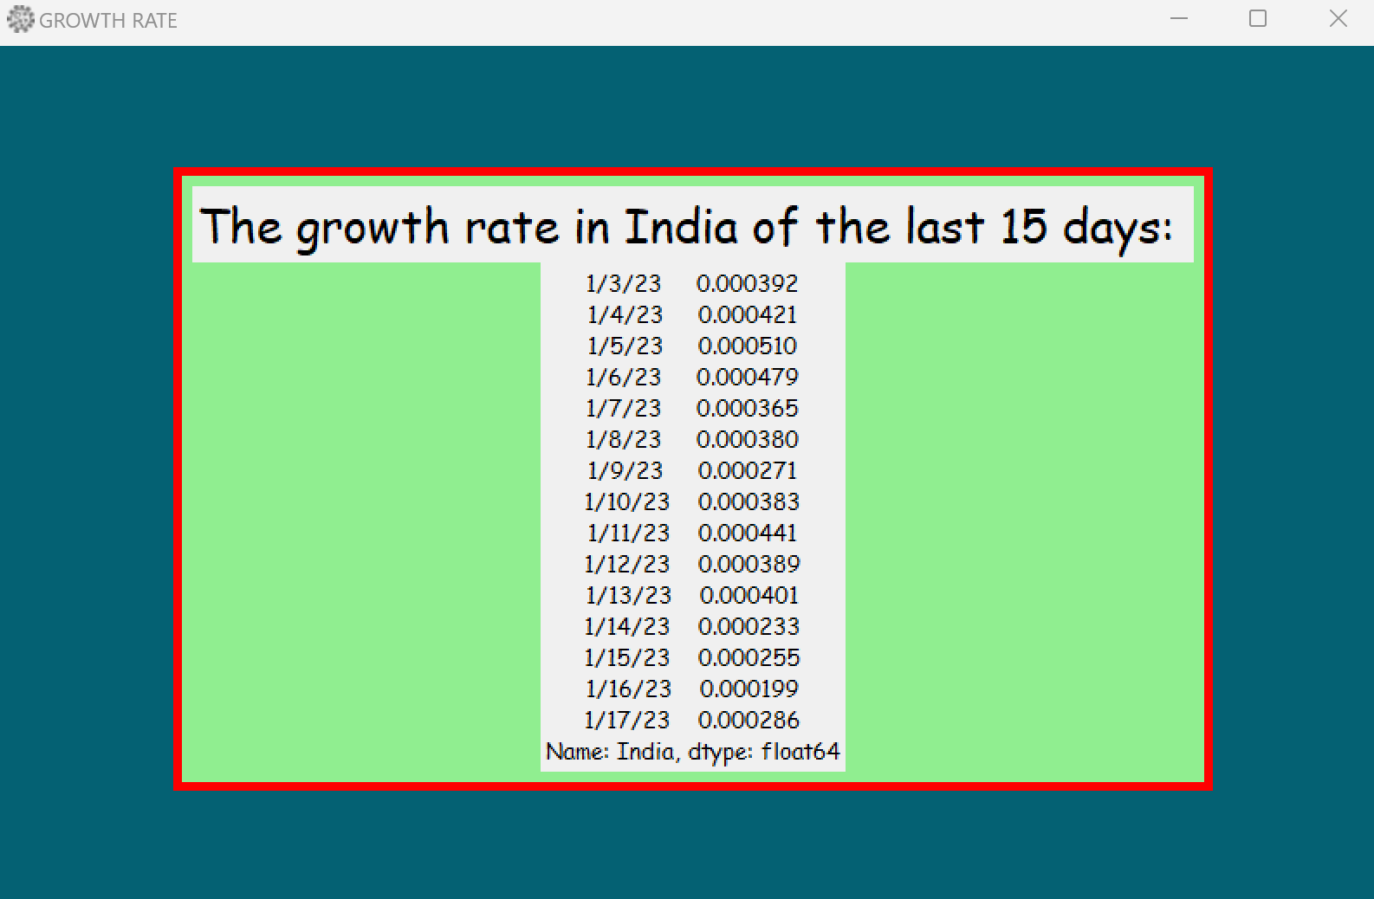

**ACTIVE CASES**

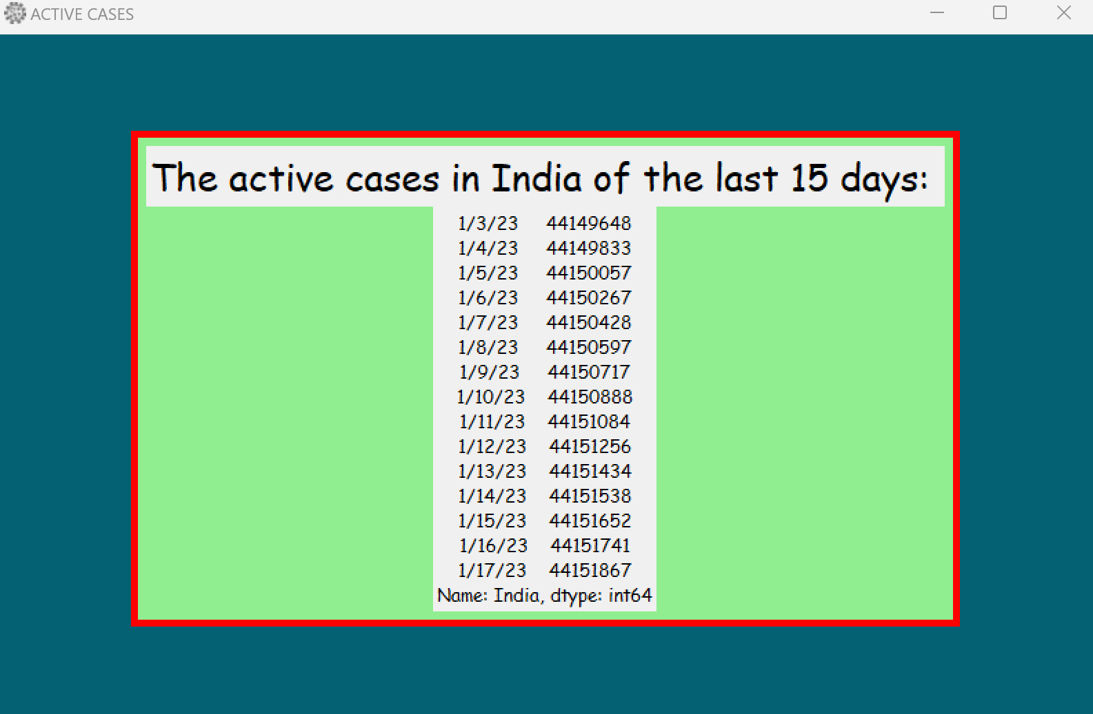

**OVERALL GROWTH RATE**

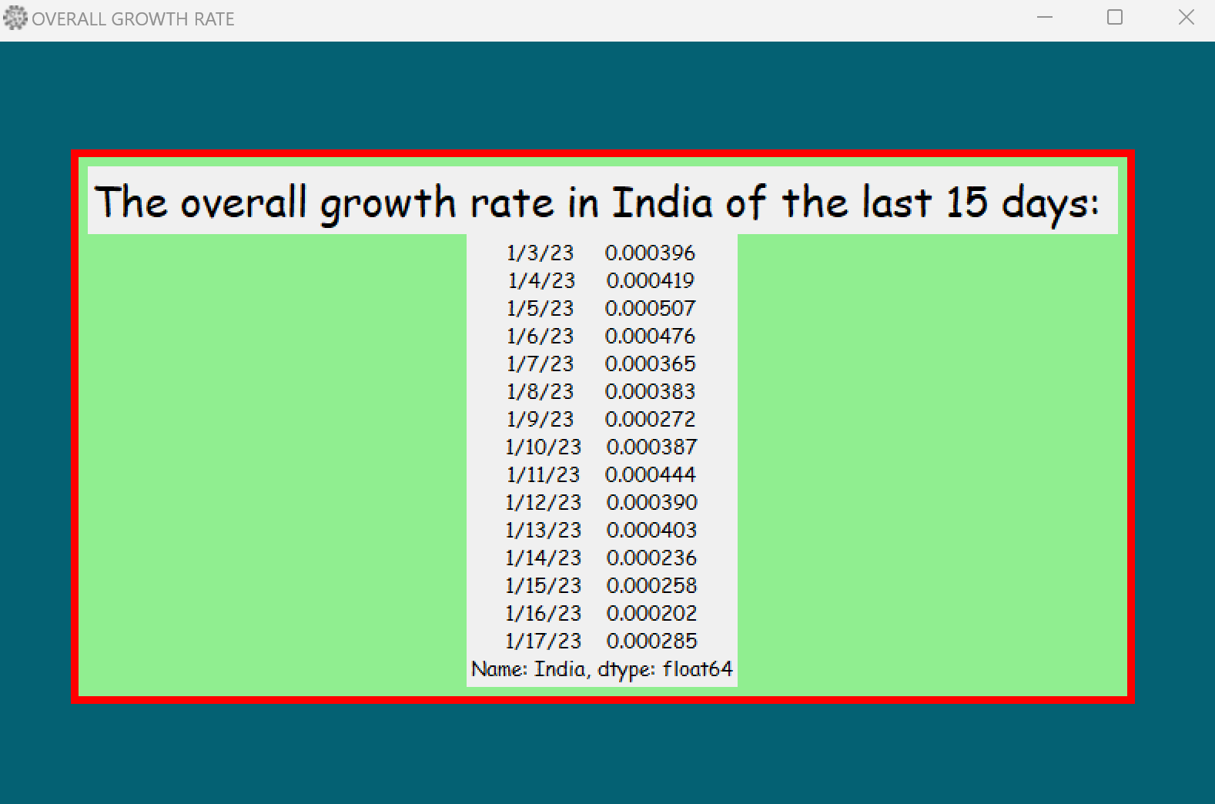

**DEATH RATE**

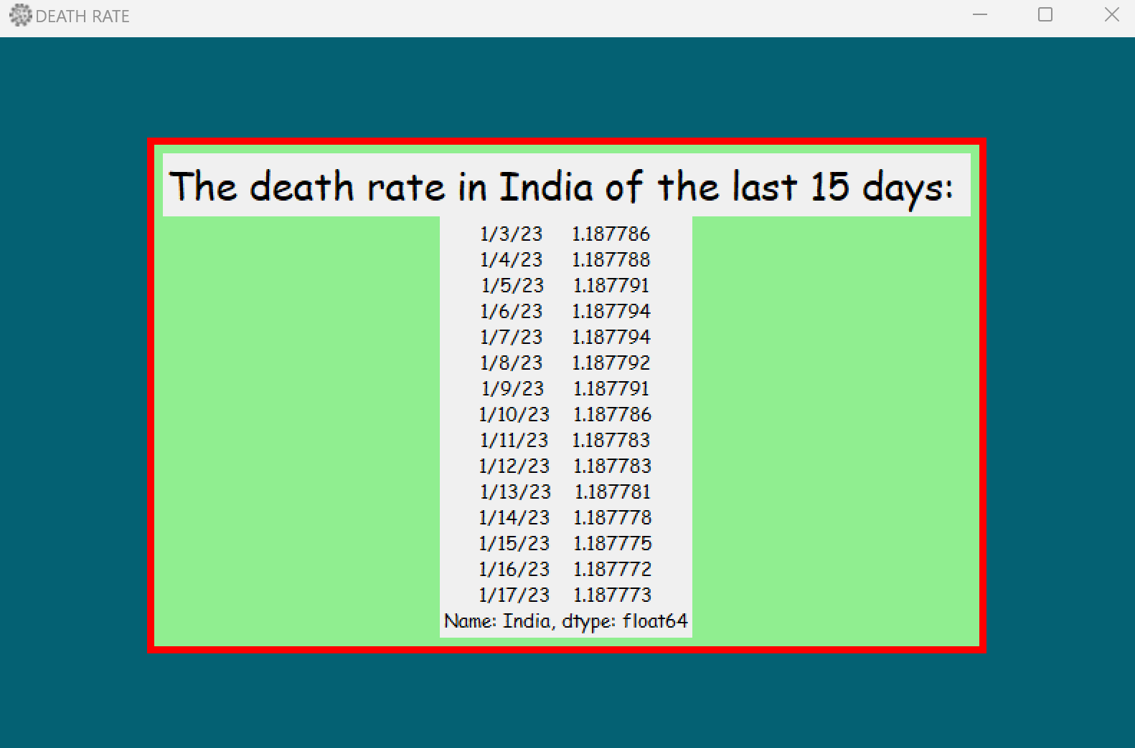

**HOSPITALIZATION NEEDED**

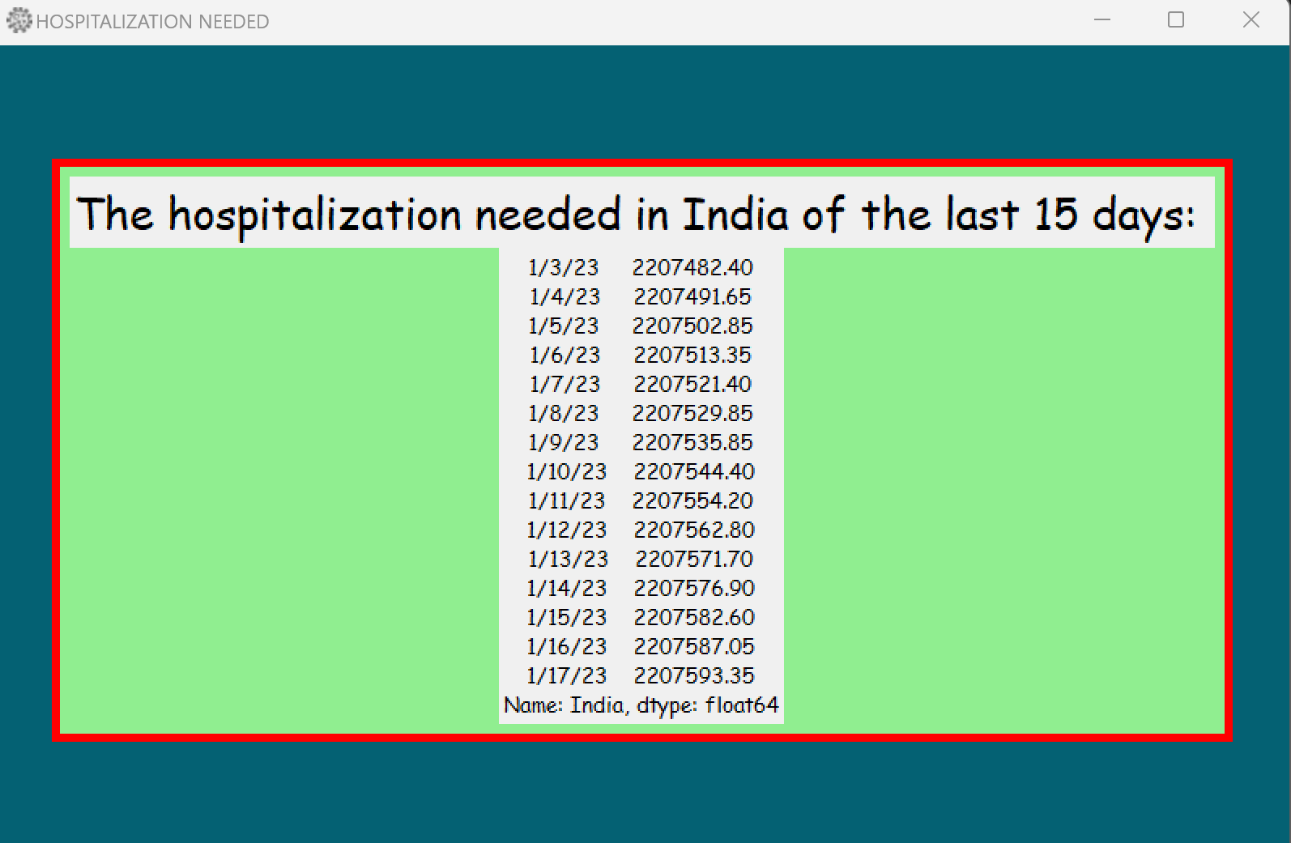

**TAKING INPUT FROM USER**

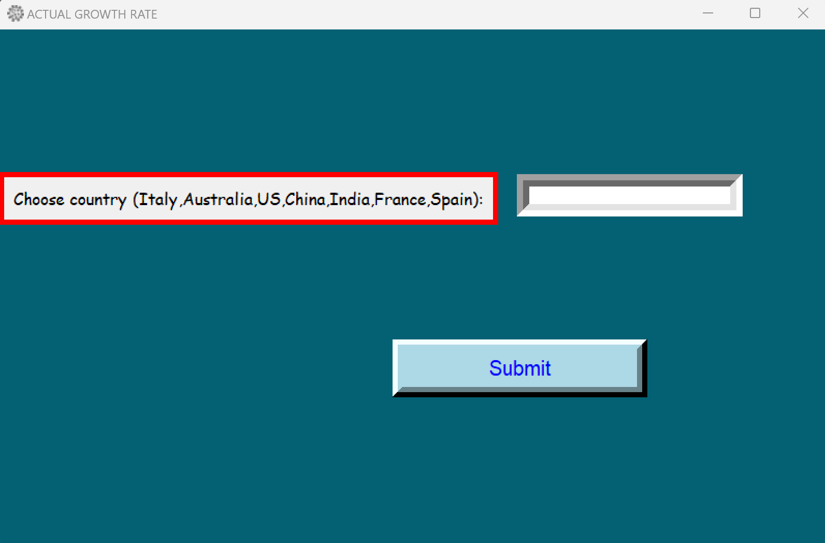

**ACTIVE CASES**

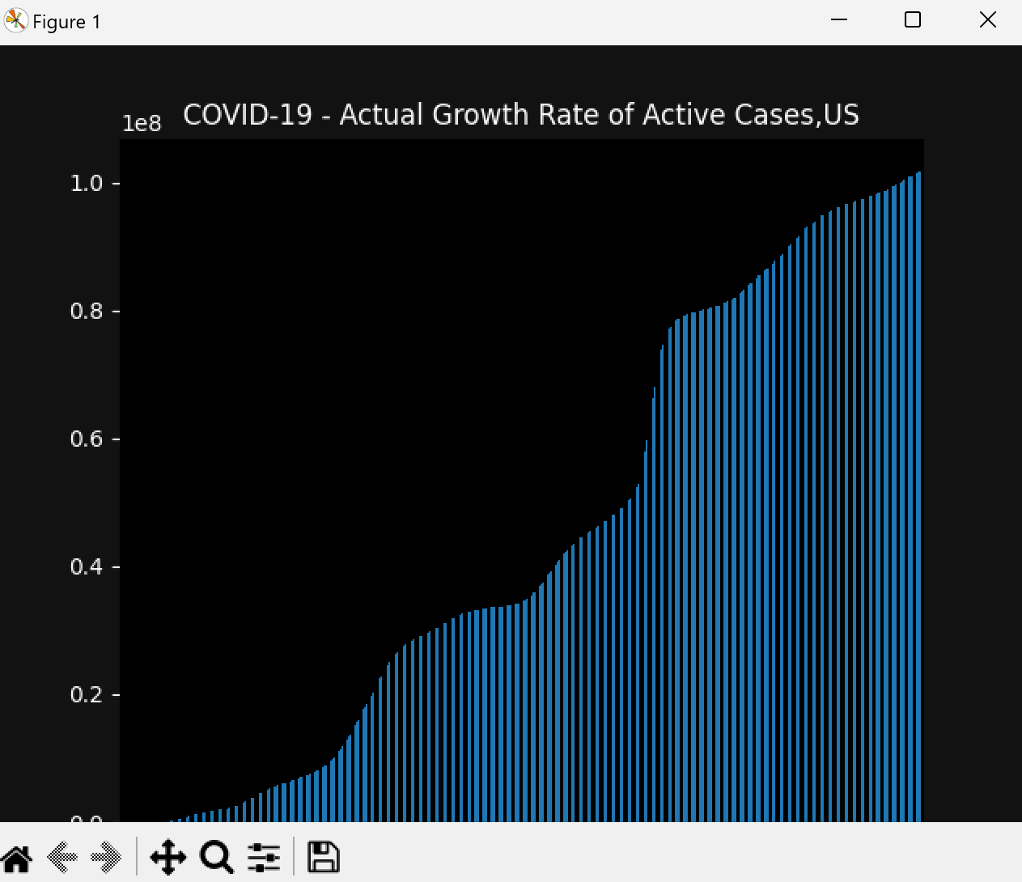

**TOTAL CONFIRMED CASES**

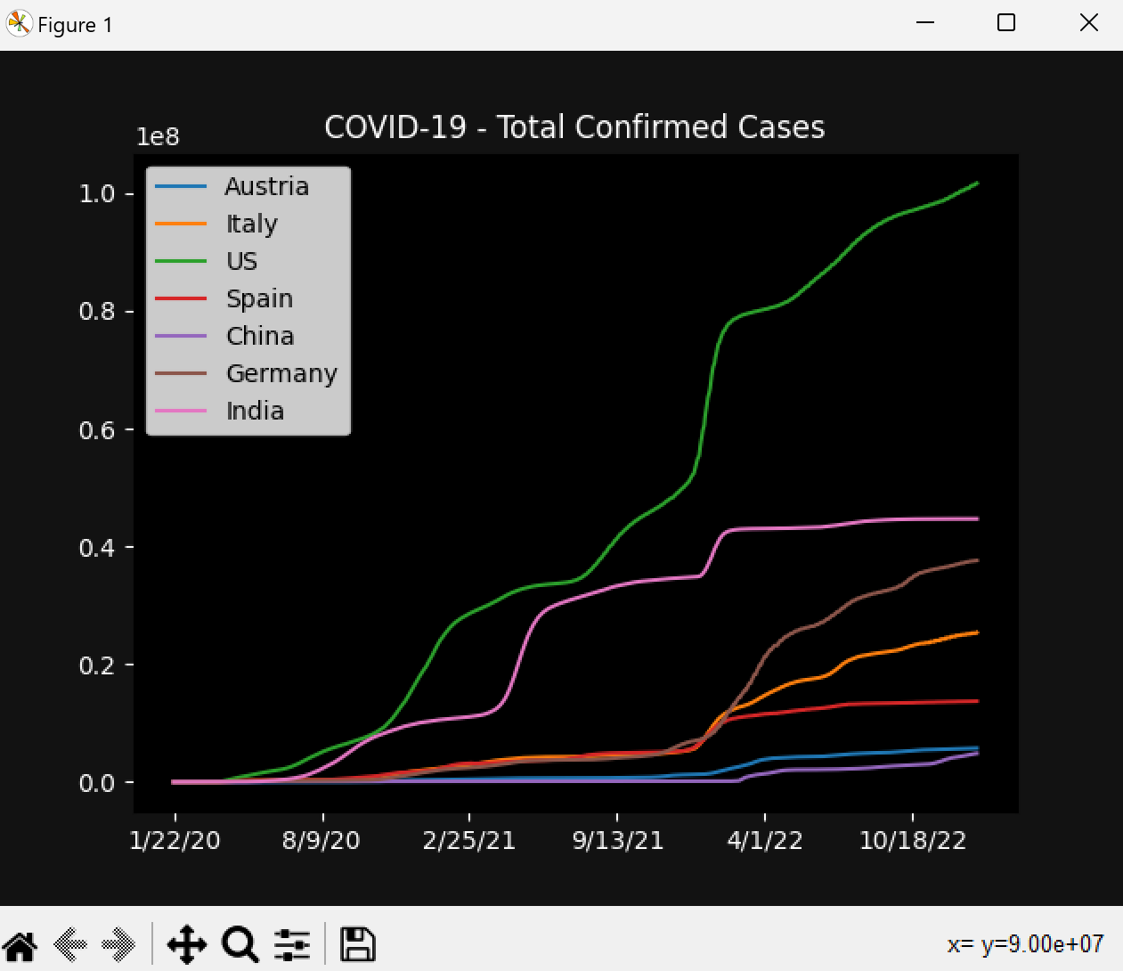

#PROJECT FEATURES / FUNCTIONALITIES:-

* It shows the information about the corona cases.
* It is easier for people to understand in graphical format.
* It can be used for understanding the variations in the cases.
* We can predict it’s rise in the future again by using the data.

#GUI LAYOUT :



